**Spring MVC Demo 4 User Guide**

1. Import ddl.sql to the MySQL named demodb4.

2. Run SpringMVCDemo4 project on Tomcat.

3. Run file Login.html in SpringMVCDemo4FrontEnd folder.

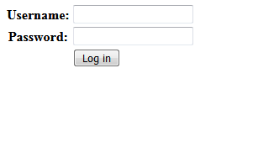

4. Login with username: admin and password: 123abc

5. We will see the Student List Page like this.

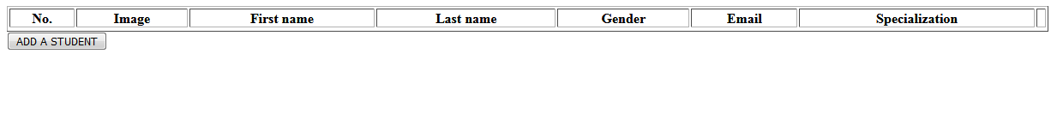

6. Click 'ADD A STUDENT' to go to the Student Adding Page.

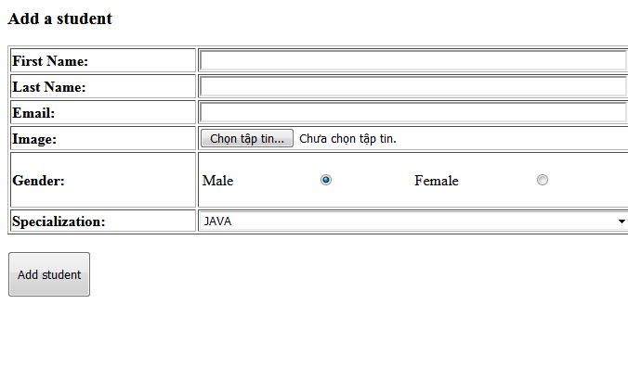

7. Fill all necessary field in the form and click 'Add student'. (remember to choose an image file for Image). It will relocate to the Student List Page with the new student, which has been added before.

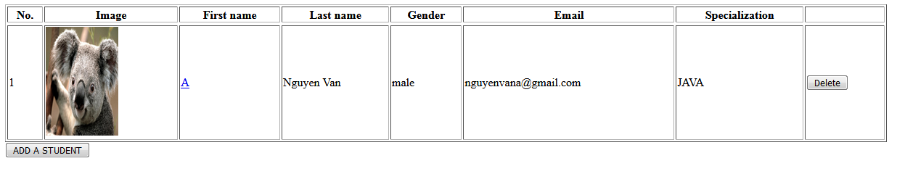

8. We can edit information of this student click on the First Name of this student. Then it will relocate to the Update Student Page with their current information except Image.

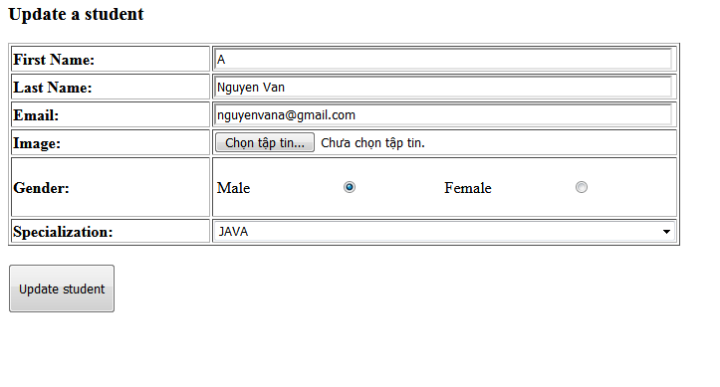

Because Image is not a primitive data type (It is a multipart-file). Therefore, if you do not want to update Student Image, we can skip that field for keeping this image. After finish editing, click 'Update student' to complete.

9. If we want to delete student, we can click button 'Delete' at each row.